Adding & Subtracting Polynomials

|  |  |
| --- | --- |
| Student Learning Objective: | Essential Question: |

Name___________________________________________________ Date___________ Period________

**Pre-Assessment Task – students will take a pre-assessment on Exponents and Polynomials**

**Mini-Lesson (Guided Notes) - Adding and Subtracting Polynomial:**

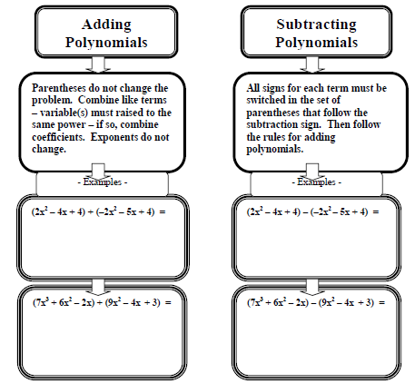

**Work Period:**

|  |  |  |  |
| --- | --- | --- | --- |
| 1). |  | 2). |  |
| 3) |  | 4) |  |

**Closing**: Which method do you prefer when adding and subtracting polynomials, horizontal or vertical?  Explain your reason.

_____________________________________________________________________________________________________________________________________________________________________________________________________________________________________________________________________________________________________________________________________________________________________________________________________________________________________________________________________________________________________________________________________________________________________________________________________________________________